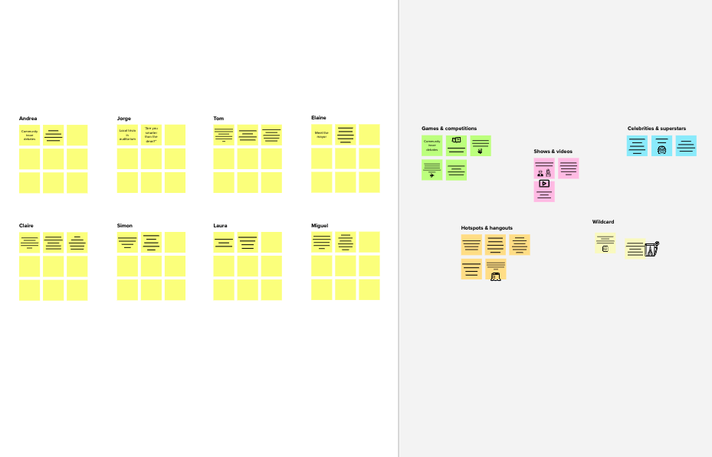

**Template**

**Brainstorm**

**& idea prioritization**

Use this template in your own brainstorming sessions so your team can unleash their imagination and start shaping concepts even if you're not sitting in the same room.

**10 minutes** to prepare

**1 hour** to collaborate

**2-8 people** recommended

**Share template feedback**

**Need some inspiration?**

See a finished version of this template to kickstart your work.

**Open example**

# Before you collaborate



A little bit of preparation goes a long way with this session. Here’s what you need to do to get going.

**10 minutes**

1. **Team gathering**

Define who should participate in the session and send an invite. Share relevant information or pre-work ahead.

1. **Set the goal**

Think about the problem you'll be focusing on solving in the brainstorming session.

1. **Learn how to use the facilitation tools**

Use the Facilitation Superpowers to run a happy and productive session.

**Open article**

**1**

# Define your problem statement

What problem are you trying to solve? Frame your problem as a How Might We statement. This will be the focus of your brainstorm.

**5 minutes**

**PROBLEM**

Now a days ,job seekers are facing difcult o fnd a suitable Job.we have come up with a solution through which job seeker can fnd the job using search option based on their skill

**Key rules of brainstorming**

To run an smooth and productive session

Stay in topic. Defer judgment.

Encourage wild ideas. Listen to others.

Go for volume. If possible, be visual.



**2**

# Brainstorm

**TIP**

You can select a sticky note and hit the pencil [switch to sketch] icon to start drawing!

Write down any ideas that come to mind that address your problem statement.

**10 minutes**

# KAMALARAJ S M

**GOVARTHAN P R**

**User can get interact with chatbot and get the job Recommendation**

**we create job alert emails,search for jobs,save them apply to them directly**

**Set timer or alert notifcation if the vacant job closing the recruitment**

**GIVE A NOTIFICATION TO ALL OF THEM FOR THE NEAREST OFFCAMPUS DRIVE**

**Create a classifer**

**that will have the capability to identify fakeand real jobs.**

**We will provide a set of courses to enhance the user's Skill and Knowledge**

**GIVE A LOGIN PAGE FOR THE HR's FOR SHARING A JOB ALERTS AND DETAILS**

**GIVE A OPTION TO REPORT THE SPAM POSTS AND DETAILS**

**PREMKUMAR R**

**HERILSON ALBERT A**



**Quick and Easy to Apply**

**Suggestion for recruiters user matched their recommended skills**

**application needed to be user friendly**

**meterics required to filtering**

**Provide a customize app for a company**

**Create Resume Making Facilities**

**Home page is**

**must**

**Get direct mail from recruiters**

**3**



**Group ideas**

Take turns sharing your ideas while clustering similar or related notes as you go. Once all sticky notes have been grouped, give each cluster a sentence-like label. If a cluster is bigger than six sticky notes, try and see if you and break it up into smaller sub-groups.

**20 minutes**

**TIP**

Add customizable tags to sticky notes to make it easier to find, browse, organize, and categorize important ideas as themes within your mural.

**User can get interact with chatbot and get the job Recommendation**

**Set timer or alert notifcation if the vacant job closing the recruitment**

**Suggestion for recruiters user**

**matched their**

**recommended skills**

**application needed to be user friendly**

**4**



# Prioritize

Your team should all be on the same page about what's important moving forward. Place your ideas on this grid to determine which ideas are important and which are feasible.

**20 minutes**

**Set timer or alert notifcation if the vacant job closing the recruitment**

**Suggestion for recruiters user**

**matched their recommended skills**

**User can get interact with chatbot and get the job Recommendation**

**GIVE A OPTION TO REPORT THE SPAM POSTS AND DETAILS**

**Importance**

**application needed to be user friendly**

**we create job alert emails,search for jobs,save them apply to them directly**

If each of these tasks could get done without any difficulty or cost, which would have the most positive impact?

**TIP**

**We will provide a set of courses to enhance the user's Skill and Knowledge**

Participants can use their cursors to point at where sticky notes should go on the grid. The facilitator can confirm the spot by using the laser pointer holding the **H key** on the keyboard.

**Feasibility**

Regardless of their importance, which tasks are more feasible than others? (Cost, time, effort, complexity, etc.)

# After you collaborate



You can export the mural as an image or pdf to share with members of your company who might find it helpful.

**Quick add-ons**

1. **Share the mural**

**Share a view link** to the mural with stakeholders to keep them in the loop about the outcomes of the session.

1. **Export the mural**

Export a copy of the mural as a PNG or PDF to attach to emails, include in slides, or save in your drive.

**Keep moving forward**

**Strategy blueprint**

Define the components of a new idea or strategy.

**Open the template**

**Customer experience journey map**

Understand customer needs, motivations, and obstacles for an experience.

**Open the template**

**Strengths, weaknesses, opportunities & threats**

Identify strengths, weaknesses, opportunities, and threats (SWOT) to develop a plan.

**Open the template**

**Share template feedback**